Dear Dr. Participating Faculty Member,

We are preparing a [new or competitive renewal] proposal for this training grant. Thank you for agreeing to participate as a faculty member on the NIH[IC] training grant, “[Title of the project]”, with Dr. John Smith.

**We will need the following information from you by April 30, 2024.**  This time-frame is necessary for on time grant submission.

1. **Research Interest:** Short summary of your related research, 1 paragraph

2.  **Biosketch**: In **Word** format.  The personal statement should include something about **mentoring** and should be relevant to this grant. Please describe your commitment to training with similar language:

* I am committed to predoc and/or postdoc training since I have trained x and y fellows.
* Training, mentoring, and promoting an **inclusive** and **supportive** scientific environment.
* Providing training in **rigorous and unbiased experimental design, methodology, analysis, interpretation, and reporting of results**.
* Aiding and supporting trainees in identifying and **transitioning into careers** in the biomedical research workforce that are consistent with trainees' skills, interests, and values.
* Fulfilling the need of the trainees to complete their **Ph.D. degrees in a timely fashion.**
* Teaching trainees to conduct biomedical research with increasing **responsibility** and s**elf-direction**.
* With respect to this application, I can provide training in the following broad areas that are associated with [grant training area] <name those areas>. “

3.  **Mentoring Records**: Please provide your mentoring records for the last 10 years in the boxes below.

| Pre-doctorates In Training | Pre-doctorates Graduated | Predoctorates Continued in Research or Related Careers | Post-doctorates In Training | Post-doctorates Completed Training | Postdoctorates Continued in Research or Related Careers |
| --- | --- | --- | --- | --- | --- |
|  |  |  |  |  |  |
|  |  |  |  |  |  |

4.  **Research** **support**: Any **changes** to current research support that you are PI or MPI on?  Please provide any other fund sources not listed.

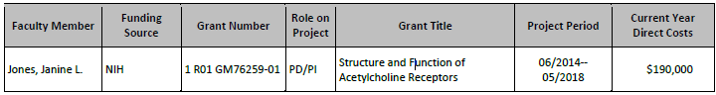

We very much appreciate your willingness to serve as a participating faculty on this grant and your cooperation in providing us with your documents in a timely manner.

Thank you,

Jane Smith