Dear Dr. Participating Faculty Member,

We are preparing a [new or competitive renewal] proposal for this training grant. Thank you for agreeing to participate as a faculty member on the NIH[IC] training grant, “[Title of the project]”, with Dr. John Smith.

We will need the following information from you by April 30, 2024. This time-frame is necessary for on time grant submission.

1. Research Interest: Short summary of your related research, 1 paragraph

2. Biosketch: In Word format. The personal statement should include something about mentoring and should be relevant to this grant. Please describe your commitment to training with similar language:
- I am committed to predoc and/or postdoc training since I have trained x and y fellows.
- Training, mentoring, and promoting an inclusive and supportive scientific environment.
- Providing training in rigorous and unbiased experimental design, methodology, analysis, interpretation, and reporting of results.
- Aiding and supporting trainees in identifying and transitioning into careers in the biomedical research workforce that are consistent with trainees' skills, interests, and values.
- Fulfilling the need of the trainees to complete their Ph.D. degrees in a timely fashion.
- Teaching trainees to conduct biomedical research with increasing responsibility and self-direction.
- With respect to this application, I can provide training in the following broad areas that are associated with [grant training area] <name those areas>. “
3. Mentoring Records: Please provide your mentoring records for the last 10 years in the boxes below.
Pre-doctorates In Training | Pre-doctorates Graduated | Predoctorates Continued in Research or Related Careers | Post-doctorates In Training | Post-doctorates Completed Training | Postdoctorates Continued in Research or Related Careers
4. Research support: Any changes to current research support that you are PI or MPI on? Please provide any other fund sources not listed.
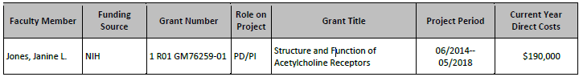
We very much appreciate your willingness to serve as a participating faculty on this grant and your cooperation in providing us with your documents in a timely manner.

Thank you,
Jane Smith

